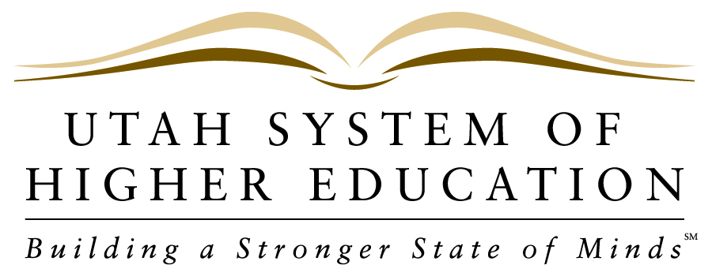 NEWS RELEASE
_____________________________________________________________________________________________

FOR IMMEDIATE RELEASE
Contact: Pamela Silberman, Director of Communications
Office: 801.321.7110
Cell: 801.633.8177
Email: psilberman@utahsbr.edu

July 11, 2013

SUU Presidential Search Committee
to Hold Public Meeting, Wednesday, July 17th

SALT LAKE CITY – The presidential search committee for Southern Utah University will hold a public meeting on Wednesday, July 17, 2013 at the Heritage Center in Cedar City. The meeting will provide an opportunity for residents of the region served by Southern Utah University to provide input into the presidential search process. Public meetings held in May allowed for community feedback on the development of the position description, which is now available at suu.edu/presidentialsearch. The search committee is now seeking input on the key personal attributes and strengths the community would like to see in SUU’s next president. The meeting will take place from 5:30-6:30pm in #7 Festival Hall at the Heritage Center, 105 North 100 East, in Cedar City.

The Utah System of Higher Education includes all of Utah’s eight public colleges and universities: The University of Utah, Utah State University, Weber State University, Southern Utah University, Snow College, Dixie State University, Utah Valley University, and Salt Lake Community College. For more information on the Utah System of Higher Education, visit our website at http://www.higheredutah.org.

