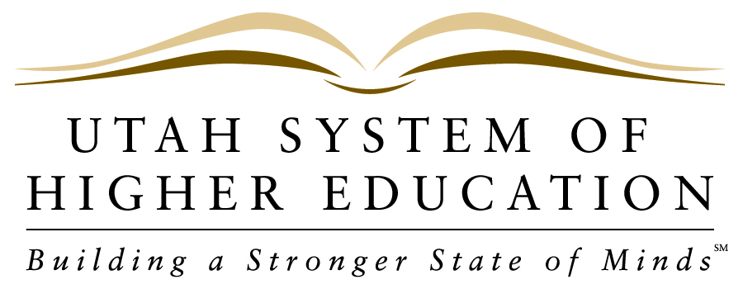 NEWS RELEASE
_____________________________________________________________________________________________
DRAFT
FOR IMMEDIATE RELEASE
Contact: Pamela Silberman, Director of Communications
Office: 801.321.7110
Cell: 801.633.8177
Email: psilberman@utahsbr.edu

December 12, 2012

Governor’s Budget is Good News for Higher Education
Funding recommendation includes key priorities for Utah’s colleges and universities

SALT LAKE CITY – The 2013-14 budget recommendation released by Governor Gary Herbert this morning contains good news for Utah’s institutions of higher education. The Governor’s budget includes the top three priorities for the Utah System of Higher Education, which are supported by the State Board of Regents and the eight institutional presidents.

The budget proposal includes an X% increase in compensation, which is the same increase recommended for state employees. It also includes $X million for Mission-Based Performance Funding, which is used to promote distinct institutional initiatives intended to increase higher education participation and completion across the state. The Governor has also allocated $X million to advance the state’s goal that 66% of Utah adults hold a higher education credential by 2020. In this first year of a seven-year plan, the Utah System of Higher Education will focus on building capacity toward graduating more students in the high growth fields of STEM (science, technology, engineering and math) and the health professions.

“Governor Herbert has followed through on his pledge to put education first and has shown true leadership in support of . These budget priorities are key to ensuring that higher education in Utah is

The Utah System of Higher Education is comprised of eight public colleges and universities governed by the State Board of Regents, assisted by local Boards of Trustees. The System includes research universities, regional universities, and community colleges. The eight USHE institutions are: the University of Utah, Utah State University, Weber State University, Southern Utah University, Snow College, Dixie State College, Utah Valley University and Salt Lake Community College. For more information on the Utah System of Higher Education, visit our website at higheredutah.org.

