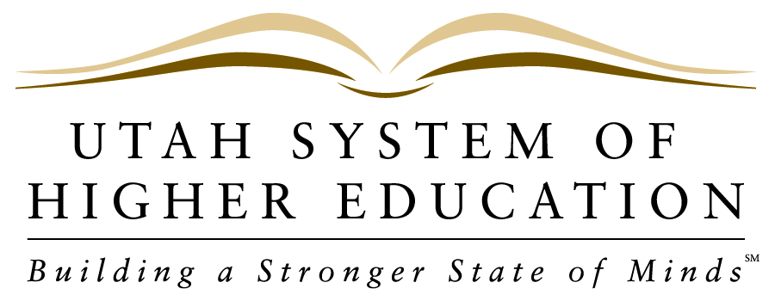 NEWS RELEASE
_____________________________________________________________________________________________
FOR IMMEDIATE RELEASE
Contact: Pamela Silberman, Director of Communications
Office: 801.321.7110
Cell: 801.633.8177
Email: psilberman@utahsbr.edu

September 14, 2012

State Board of Regents Approve 2013-2014 Higher Ed Budget
& Prioritize Capital Facilities Requests

LOGAN, UT – During its September meeting, held today at Utah State University, the State Board of Regents approved the Utah System of Higher Education’s 2013-2014 budget request of $49,396,000, which includes $16 million for Mission-Based Performance Funding and $20 million to move forward Utah’s goal that 66% of adults hold a higher education credential by 2020. The budget also includes $10.4 million in operational expenditures in infrastructure and technology and $2.95 million for student access initiatives and collaborations. Another $14 million was approved for state initiatives that will increase class size at the University of Utah’s School of Medicine and implement Dixie State’s university status.

The Regents also approved a prioritized the list of state-funded capital development projects submitted by USHE institutions. The list has Weber State University’s new Science Lab Building, with a requested $60.9 million in state funds, and Utah Valley University’s Classroom Building, with a $53.2 million state request, sharing the top spot. Following in order of priority are: Snow College Science Building Reconstruction,$11.8 million; Utah State University Biological Sciences Building, $60 million; USU-Eastern Central Instruction Building, $20 million; Salt Lake Community College CTE Classroom and Learning Service Building, $15 million; and Dixie State College East Elementary School purchase, $1.5 million (which was jointly recommended on the list of landbank projects.)

The budget request and building priorities will be submitted to Governor Herbert for his consideration as he makes his overall recommendation to the Utah State Legislature for the upcoming 2013 legislative session.

About The Utah System of Higher Education: USHE includes all of Utah’s eight public colleges and universities: The University of Utah, Utah State University, Weber State University, Southern Utah University, Snow College, Dixie State College, Utah Valley University and Salt Lake Community College. For more information on the Utah System of Higher Education, visit our website at http://www.higheredutah.org. Follow USHE on Facebook and Twitter.

###

